DIRECTIONS

From Ottawa:
Take Hwy 417 east to exit #58. Drive 29 km south on #138 to the traffic light in St Andrew’s West (Quinn’s Inn on the corner). Turn left on #18 and drive 18.8 km, through Martintown and past McCuaig’s Corners to #19. Watch for the green sign pointing to Williamstown. Turn right and proceed 6.6 km down #19 to Williamstown. When you get to the stop sign, turn left and go 0.5 km to Char-Lan High School for parking and registration. Proceed to the fairgrounds, about 0.7 km west of the school. Footrace starts by the “Meeting Place”.

From Quebec:
Drive west on Hwy 20 and continue on Hwy 401. Take exit #814 to Lancaster. Drive 0.7 km north to #17 (Pine St). Turn left and go another 7 km to Williamstown. For parking and registration, Char-Lan High School will be on the right as you enter the village. For the footrace, continue another 0.7 km along #17 to the fairgrounds.

From Kingston/Toronto:
Drive east on Highway 401 about 10 km past Cornwall. Take exit #804 at Summerstown Station. Drive 5.5 km north on #27 until you get to the stop sign. Turn right and proceed 4.9 km to the stop sign in Williamstown. Turn right and go about 0.5 km to Char-Lan High School for parking and registration. Proceed to the fairgrounds, about 0.7 km west of the school.

ADDITIONAL INFORMATION
Sheila and Wendell Lafave (613) 347-3206
swlafave@sympatico.ca or Susan Kersley (613)-347-1928 susan.kersley@sympatico.ca

www.greatraisinriverfootrace.com
www.williamstownfair.com




  Hunt Insurance a division of Johnson Inc., Cornwall | 
 | Justin’s No Frills  
Fantastic Dry Cleaners | 
 | 
 | 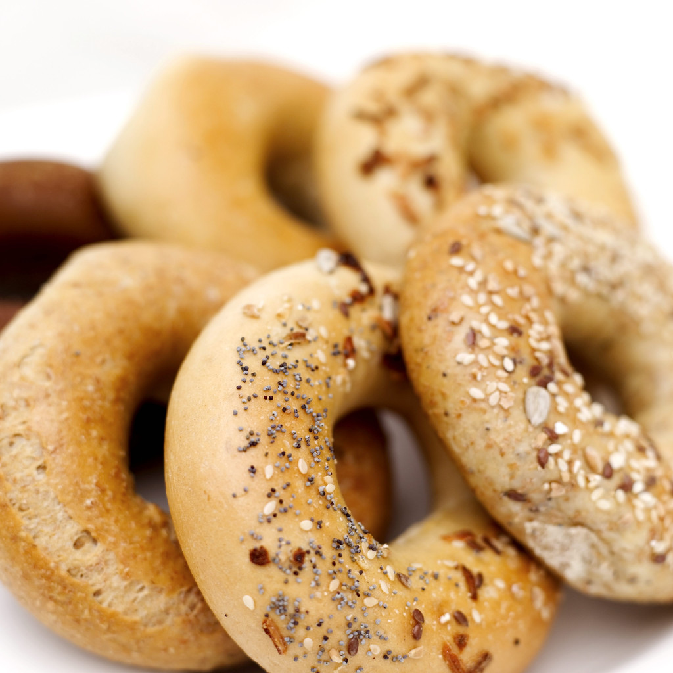  Lanthier Bakery
Polar Sound DJ Services | Ray-Jans Construction

33rd Annual
CHARITY – FREE THE CHILDREN
Support our local high school students in their efforts to make a difference in the world through Free The Children. Funds raised will go towards building a school in Kenya. Visit Free the Children at: www.freethechildren.com



Great Raisin River Footrace
Williamstown, Ontario


11K / 5K
August 7, 2011
9:00 a.m. Start

Featuring

TANIA JONES
One of Canada’s Most Accomplished Runners

Latest Footrace News for 2011:

Total Number of Participants in the Great Raisin River Footrace will be capped at 500. Enter early and don’t be disappointed!

Bibs to incorporate the latest chip technology featuring a disposable chip attached to the back of the bib. No more worries with the velcro ankle chip!
COURSE DESCRIPTION
All runs start on the Fairgrounds, beside the “Meeting Place”. The 11K is a scenic, flat, run on a country road, the second half being gravel. It runs along both sides of the river and finishes back in the Fairgrounds. The 5K is an out and back.
Kids Fun Run: There will be a free 150 metre fun run for children under 12 years of age. Kids will receive a ribbon and a treat.

SCHEDULE OF EVENTS - AUGUST 7

7:00-8:30 am Race Kit pickup and Late Registration @ Char-Lan High School, Williamstown
8:45 am Kids Fun Run
9:00 am Start 11K & 5K
10:00 am Food and Refreshments
10:15 am Awards and draw prizes

RESULTS
Chip timing provided by SPORTSTATS. Results will also be posted on our website:
www.greatraisinriverfootrace.com

AWARDS & PRIZES
- Medals for top 3 in all categories

MEDICAL SUPPORT: St John Ambulance.
FACILITIES ON SITE
Toilets & showers at registration site, Char-Lan High School, available until 11:00 am.

AID STATIONS
Look for water at the 2K, 5K, 7K and 9.5K and of course at the finish line.

FOOD & REFRESHMENTS: at finish area.

ONLINE REGISTRATION AVAILABLE AT:

www.greatraisinriverfootrace.com

SPECIAL THIS YEAR

Free Saturday evening 6:00 pm Fun Run and Clinic with Tania Jones.

About Tania (www.taniajones.com):
- 2002 Canadian Marathon Champion
- 2011 Bermuda Half-Marathon Winner
- One of Canada’s top three ranked marathon runners for eight years

Tania is the only female to win over the entire field in the 1999 11k Footrace.

Duels Along the Raisin River

Duel #1 – Tania will challenge last year’s winner, Francois Menard-Kilrane, in the 11k. (Francois came second to Tania in 1999!)

Duel #2 – 80 year old Ed Whitlock, the world’s fastest marathon runner 80+, will take on local runner Phil Barnes, age 39, in the 11K.

Runners Please Note: Your bib is your entry to the fair.

ENTRY FEES for 5K & 11K

$15 up to July 15

$20 from July 16 to August 4, midnight

$25 after August 4

$60 family rate – family of 4 or more

Cheques payable to:

GREAT RAISIN RIVER FOOTRACE
To enter, mail or drop off entry form and fee to:
Susan Kersley, 19634 William Street,
Williamstown, ON K0C 2J0

ENTRY FORM

________ 11K ________ 5K

Name: _________________________________
Address: _______________________________
______________________________________
E-mail:_________________________________
Phone: _________________________________
Date of Birth __________________ Age ______
Gender: Male _____ Female ______
Waiver of Liability: Please enter me in the GREAT RAISIN RIVER FOOTRACE. I am participating at my own risk and waive all claims of every nature against the organizers, officials, the Ontario Roadrunners Association, the Ontario Track and Field Association, Williamstown and the sponsors with respect to personal loss or bodily injury resulting from participating in an activity such as this. I also fully understand the rigours of such a competition and I have prepared myself physically for the race. Participants may be required to sign an additional waiver at registration.

____________________________________
Signature (Guardian if under 18)

Race T-shirt optional : 100% cotton - $15

Optional T-Shirt: S____M_____ L____ XL ____

Payment:
Race Entry paid by July 15 | $15 | $
Race Entry July 16 – Aug. 4 | $20 | $
Race Entry after Aug. 4 | $25 | $
Family Rate – Family of 4 or more | $60 | $
Race T-shirt (available while quantities last) | $15 | $
Total enclosed |  | $

